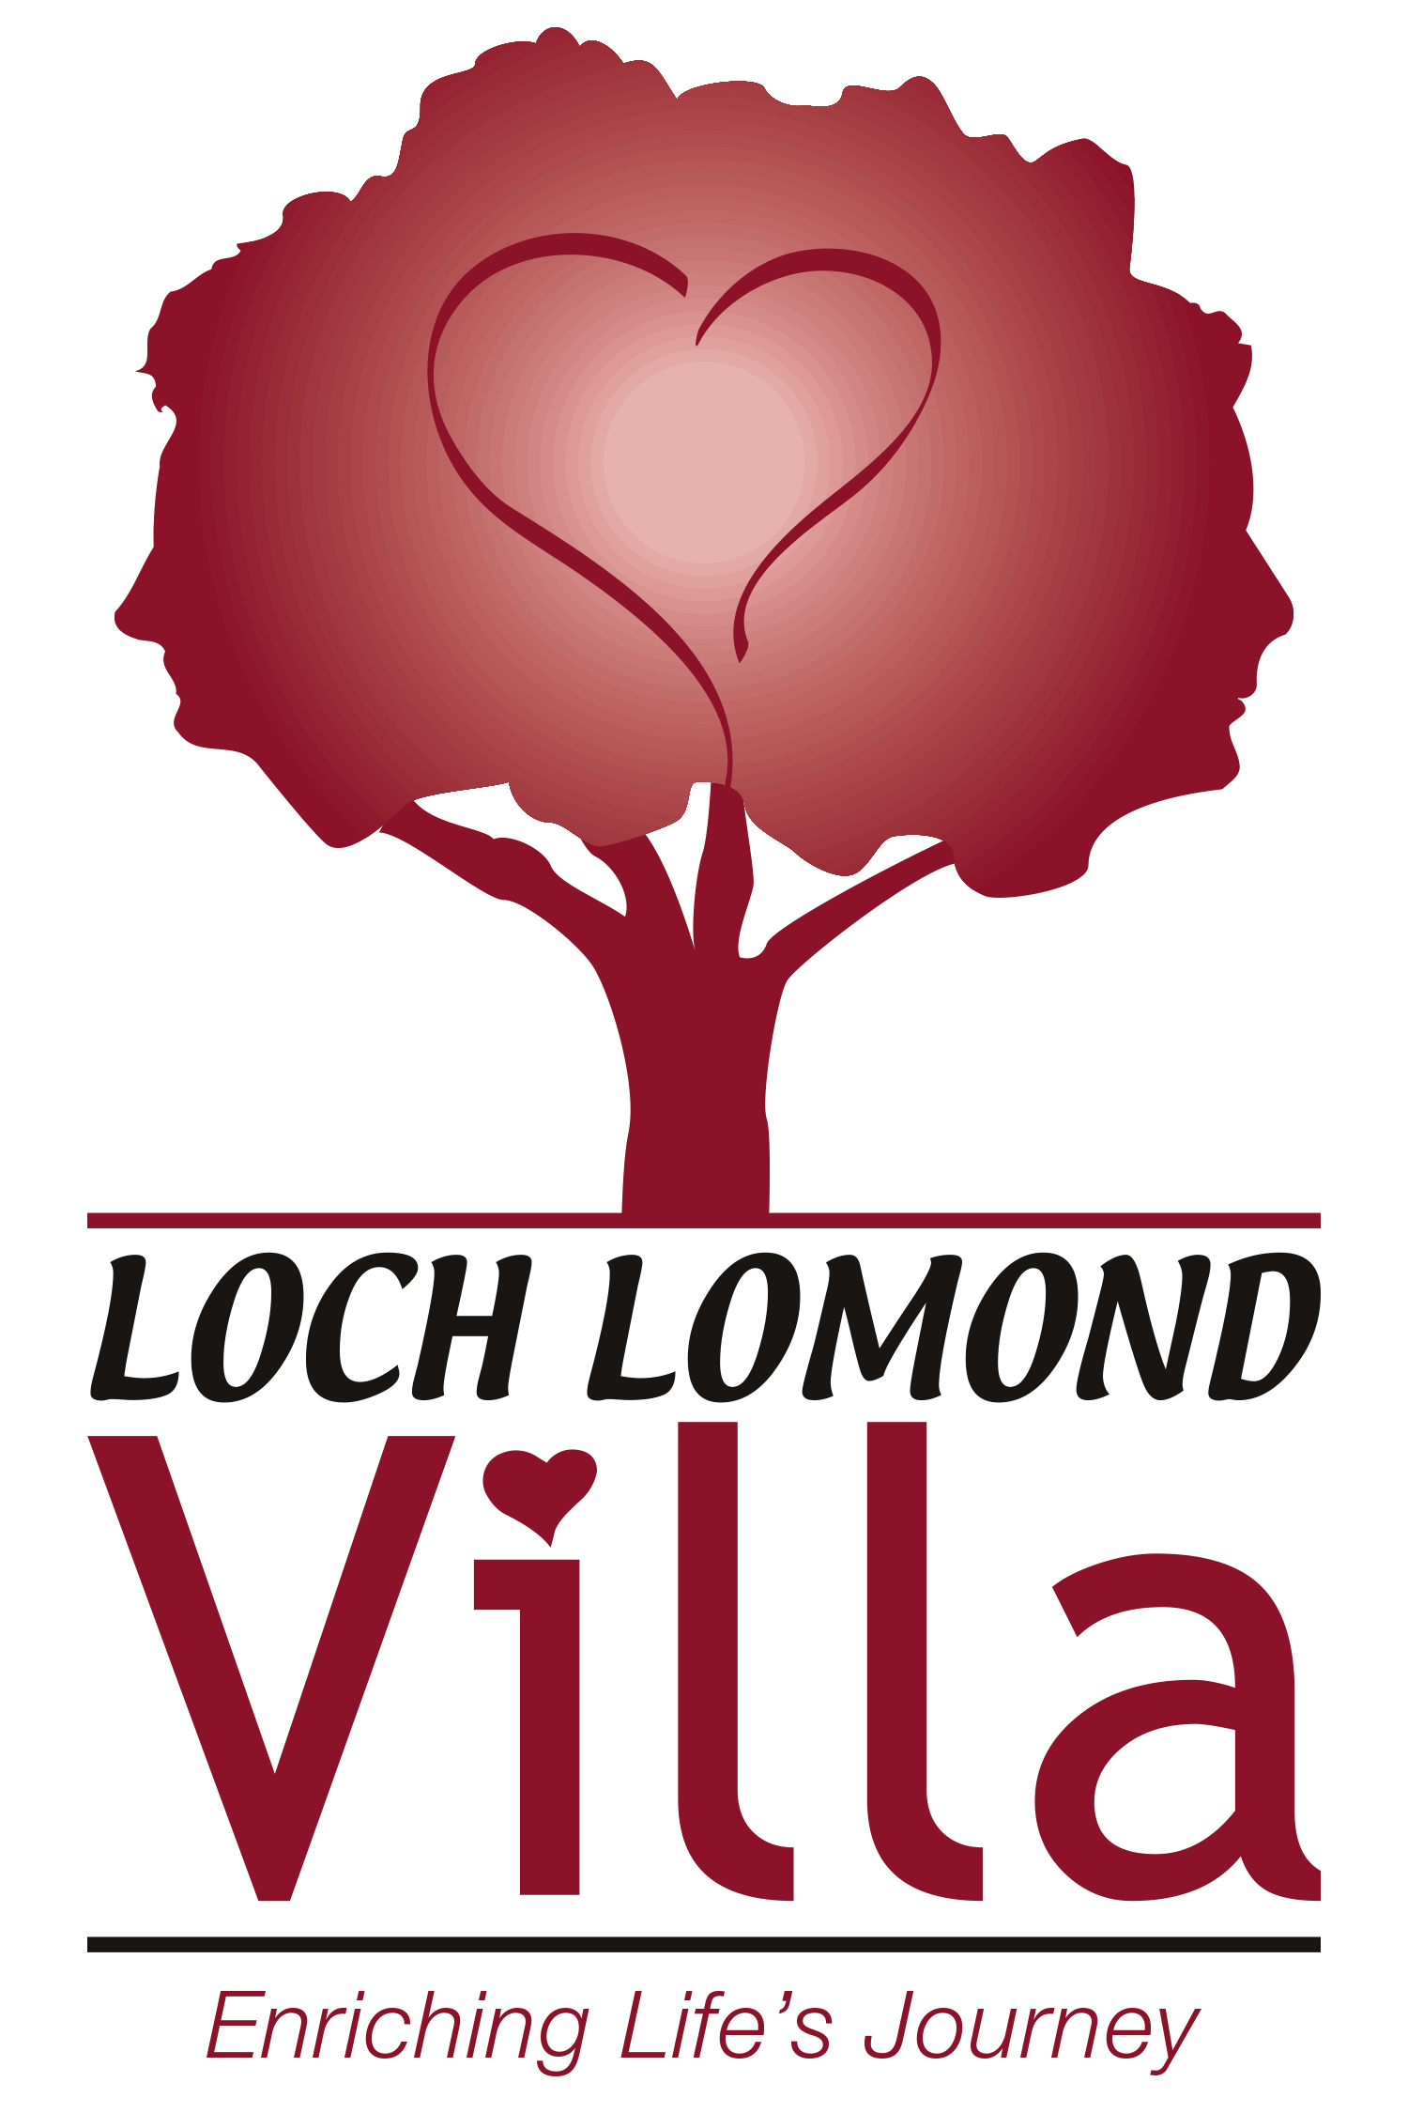
LOCH LOMOND VILLA, INC.
185 Loch Lomond Road, Saint John, New Brunswick, E2J 3S3
Telephone: (506) 643-7175 ♦ Fax: (506) 643-7198
www.lochlomondvilla.com

Date: February 16th, 2021
To: Families and Residents
From: Cindy Donovan, CEO
Re.: COVID Update

Essential Care Partner Program

On February 10th, Loch Lomond Villa performed 107 COVID Sentinel Tests for our Essential Care Partners in preparation for once again welcoming back our ECPs into the home. The clinic was run very efficiently, and we thank our NP Adam and RNs Angela, Susan and Maddy for stepping up to make this possible. We must also thank Public Health for permitting us to provide the sentinel testing clinic for our ECPs. I must stress that the designated ECP can begin visiting as per the schedule on Tuesday February 16th if they have been advised by Public Health that they have a negative result from their COVID swab. ECPs are required to be actively screened upon entry to the Home and will be asked to report their COVID test results. We thank you for your cooperation and understanding that our residents and staff’s safety is a priority. All ECPs will be notified of the next COVID sentinel testing clinic soon. By now, the ECP schedule has been developed and confirmed with all the designated ECPs. We are all looking forward to welcoming our ECPs back this coming week.

Moderna Vaccine

We are thrilled to share with you that our residents will be receiving their 2nd dose of the Moderna Vaccine on Wednesday February 17th. During this massive immunization clinic, residents are monitored closely for any possible side effects from the vaccine. On January 20th when our residents received their 1st vaccine, we were very pleased that there were no adverse reactions to the vaccine. Once again, our dedicated vaccine teams, made up of 31 Loch Lomond Villa staff, have been busy preparing for the second vaccine clinic this week.

We have had a few residents move into our homes since January 20th and had not previously received their 1st Vaccine. These new residents will receive their 1st Moderna vaccine on February 17th, along with any of our residents that were ill on January 20th and therefore were not able to receive their 1st vaccine. Public Health is developing the process for any residents that will require their 2nd vaccine after our mass vaccine clinic is held this Wednesday.

Quality Measures

Attached to this update, is information regarding quality measures that we track through our Medical Advisory/Quality Management Committee. We would like to share with you these results.

